Study Guide - Solutions

Don’t just memorize the answers on this study guide; understand them. On the test, you will get full credit for everything you can do from memory and half credit for anything done with the help of Python.

- Explain the difference between each of the following pieces of Python code.

x = 2 x != 2

Sol. The first assigns the value of 2 to a variable, x. The second is a Boolean that checks whether the variable x equals something other than 2.

- Circle the following Boolean expressions that are False and explain why.

‘1’(string) == 1 (integer) 1 >= 2 (1 is less than 2)

‘1’ == “1” 2 > 1

True != False 1 != 2

(1 > 5) == (1 + 1 == 3) False == ((4 < 2) or (2 <= 2)) (left side is false and right side is true, because 2 is equal to 2)

- What is the output of the following code snippet?

x = 6 + 7//2
print(x)

Sol. 9 (the double division is floor division that removes any trailing decimal)

- What is the output of the following code snippet?

x = 3
if (x >= 2):
print(“x is out of bounds” + str(x))
else:
print(“x is great” + str(x))

Sol. x is out of bounds3

- What is the output of the following code snippet? What would happen if x were assigned True instead of False?
x = False
while (x):
print (“Ta Da”)
print(“Lovely”)
Sol. Lovely; if x were true, it would be an infinite loop that kept printing Ta Da

- What is the output of the following code snippet?
sum = 0
for num in range (1, 3):
sum = sum + num
print(sum)
Sol. 3

- What does the code snippet below do? You will need to describe it in terms of the input.

x = float(input())
if (x >= 0):
print(x)
else:
print(-x)
Sol. It takes any number and prints the absolute value of that number.

- What does the code snippet below do? Again you will need to describe it in terms of the input.

x = input()
for i in range(1, 5):
line_str = “”
for j in range (1, 6):
line_str = line_str + x
print(line_str)
Sol. Prints four rows, each with five copies of the input.

- How would changing the 6 in the program to i + 1 change the output?

Sol. It would still print four rows. The first row would have one copy of the input, the second would have two copies, the third would have 3 copies, and the final row would have 4 copies.

- Write a piece of Python code to read in a value from the user and then print out the name of the number if the number is between 0 and 10 inclusive and if it is not print “out of range” (Note: Don’t use more than 1 if statement.)

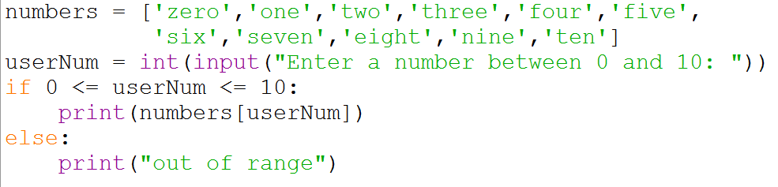

- Write a piece of Python code that will compute the circumference of a circle using the formula C = 2πr and 3.14 for π.

- Write a Python program (with a loop) to print out the odd numbers from 1 to 1001. (i.e. 1, 3, 5, 7, 9, …, 1001)

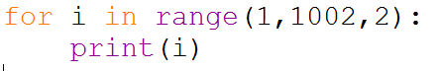

- Be able to write simple Python functions for (without using built in functions for min, max or using the in operator…)
- def minimum(a, b, c): # where a, b, and c are numbers
- def summ(data): #where data is a list of values
- def maxx(grades): # where data is a list of grades and you should return the biggest
- def first_half(string): # return the first half of the string (assume even number of characters)
- def has13(data): # return True only if 13 is somewhere in the list of numbers
Example solutions follow; understand, don’t memorize! The actual questions will not necessarily ask you for the exact same output!
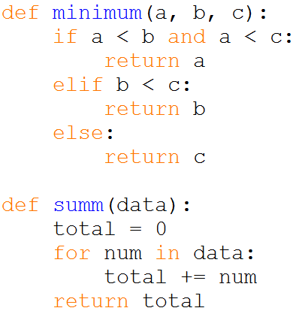
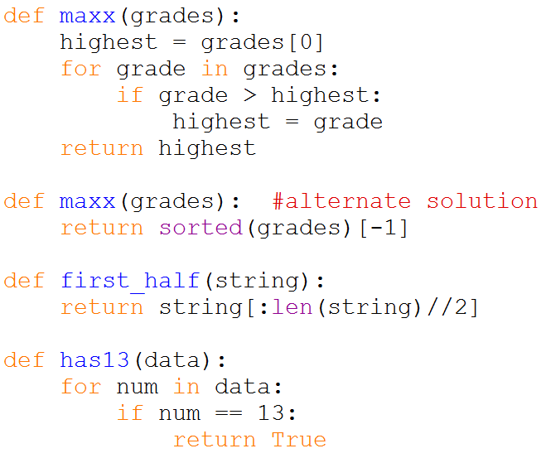

- Write a short Python program to get a string from the user and print out a new string that has the first and last characters of the input string switched.

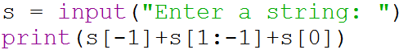

- What does the following code do?

x = 4
while True:
for x in range(6):
y = 2*x+1
print(y)
if y > 9:
break

Sol. Prints out an infinite loop of 1,3,5,7,9,11 (each on a separate line).

- Read a list of numbers from the user, detecting the end of the list when a non-number is entered. Print the average of the numbers that were read so far.

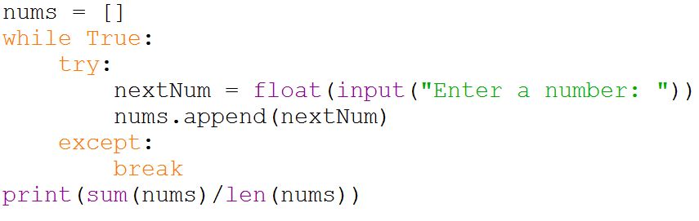

- Finish defining the following function that finds the minimum number in a list of numbers and returns it.

def listmin(L):
return min(L)

- Find the errors in the following codes. [Expect both syntax and logical errors.]

- x = 7
while x != 0: (while x>=0 is better to ensure that the loop eventually ends)
print(x)
x -= 2

- while True:
x = input("? ")
if x == "quit" or x == "": (needs two equals signs in each)
break

- Typically, a return statement in a Python function can only return a single value. Explain how you could return 3 values from a Python function with a single return statement.

Sol. Could return 3 values inside a single tuple or a single list.

- Trace these three programs by keeping close track of what the variable i is at every step along the way.

- for i in range(5):
print(i, i*i)

- def squares(i=5):
i = i - 1
if i > 0:
squares(i)
print(i, i*i)
squares()

- for i in range(2,7):
print(9-i)

Sol. Use http://pythontutor.com/visualize.html#mode=edit to check answers.

- Know the differences between if, elif, else, for, and while.

Sol. Use Google and our textbook resources!

- Fix the errors in the following function:

def showFractionAsDecimal:
_1st = input(“Enter the fraction numerator: “)
_2nd = input(‘Enter the fraction denominator: ‘)
print _1st “/” _2nd ‘ is “ _1st // _2nd

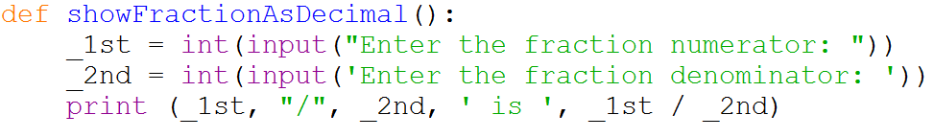

- What would be all of the output of the following function when called on the number 4?

cache = {0:1,1:4}

def fibPlus(x):
if x not in cache:
cache[x] = fibPlus(x-1) + fibPlus(x-2)
print(x, cache[x])
return cache[x]

Sol. 2 5 (For explanation, see https://www.youtube.com/watch?v=nAz1VrHM4n8)
3 9
4 14
14

- Assume that x = [2, 3, ‘r’, 5, ‘turtle’, 2, 4]. Write a list comprehension that will change x by removing all of the nonintegers.

Sol. x = [i for i in x if type(i) == int] #This is fine for our purposes
x = [i for i in x if isinstance(i,int)] #This is a slightly more precise code

- Consider the following Python code.

with open(myFile,”r+”) as f: #Line 1
contents = f.read() #Line 2
contents2 = f.readlines() #Line 3
for character in contents: #Line 4
ascii = ord(character) #Line 5
newascii = asci + 1 #Line 6
character = chr(newascii) #Line 7
with open(“myFile2”,”w+”) as g: #Line 8
g.write(contents) #Line 9

(a) What happens if myFile doesn’t exist? FileNotFound error
(b) What is the difference between Line 2 and Line 3? Line 2 reads in the contents of the file as a string; Line 3 reads it in as a list of strings where each string is a line from the file.
(c) Assuming that myFile is an existing file, what does this program do? It creates a second file (myFile2) with exactly the same contents as myFile (although that’s probably not what it is intended to do – see part (d))
(d) If the programmer wants myFile2 to be an encoded version of myFile, how can he/she do that with only minimal changes to the above code? Between Line 3 and Line 4, she could set up a blank string, say encrypted. Then Line 7 could be rewritten as encrypted += chr(newascii).

- Name one situation where it would be better to use…

  - A list instead of a dictionary
  - A dictionary instead of a list
  - A list instead of a tuple
  - A tuple instead of a list
  - A list instead of a set
  - A set instead of a list

- What would be the Boolean output of {3, 5, 4} == {4, 5, 3, 3, 5}? Why?

Sol. True. Sets count duplicate items as a single item. Both sets simply contain the elements 3, 4, and 5.

- Dictionaries and sets both use curly braces {}; how can you tell them apart?

Sol. Each element in a dictionary is a key:value pair; elements in a set can be of any variable type. To tell the difference, you could use the type() function on a variable.

- Explain the error in the following code and one way to avoid it.

meaning = 42

def myFunction():
print(meaning)
meaning = 100

myFunction()

Sol. meaning is originally defined outside of the function in the global scope. Inside the function (i.e., the local scope), this variable can still be called, but it cannot be changed. This could be avoided by making the first line of the function, global meaning

- For each of the following attempts at a function, find the error. (Note: The function is designed to take a word and capitalize every letter.) Then write a function that correctly uses a for loop to iterate through each letter of a string and capitalizes it.

def capitals(word):
for letter in word:
letter = letter.upper()
return word #word is never actually changed throughout the function

def capitals(word):
solution = ‘’
for letter in word:
letter.upper() #the capitalized letter is never saved in solution
return solution #solution is never actually changed throughout the function

def capitals(word):
capWord = ‘’
for letter in range(len(word)):
capWord += letter.upper() #letter is an integer part of the range, not a character from word.
return capWord

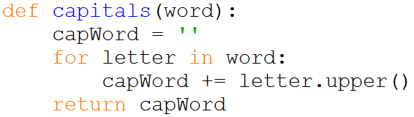

- For each of the following, state whether the x[0] command will produce an error and, if it’s an error, explain why.

x = 'new York'
x[0] = 'N' #Error. Strings are immutable.

x = ['n','e','w']
x[0] = 'N' #No error.

x = {'n','e','w'}
x[0] = 'N' #Error. Sets are not ordered and thus are not indexed.

x = ('n','e','w')
x[0] = 'N' #Error. Tuples are immutable.

